Toy Model #4

The equations that define the simple Toy Model are described in Equations 1 and 2.

|  |  |  |
| --- | --- | --- |
|  | $$\frac{dΦ}{dt} =-βV+\frac{Φ^{3}}{3}- Φ =L_{Φ}$$ $$\frac{dV}{dt} =βΦ+ α =L_{V}$$ | (1)  (2) |

Then with diffusion added Equations 1 and 2 become 3 and 4 as follows;

|  |  |  |
| --- | --- | --- |
|  | $$\frac{dΦ}{dt} =D\frac{d^{2}Φ}{{dx}^{2}} + L_{Φ}$$ $$\frac{dV}{dt} =D\frac{d^{2}V}{{dx}^{2}} + L_{V}$$ | (3)  (4) |

Where α and β are variable parameters

# Results 1

Due to there being two parameters it is important to view the interaction between the two. First if you hold α constant and vary β:

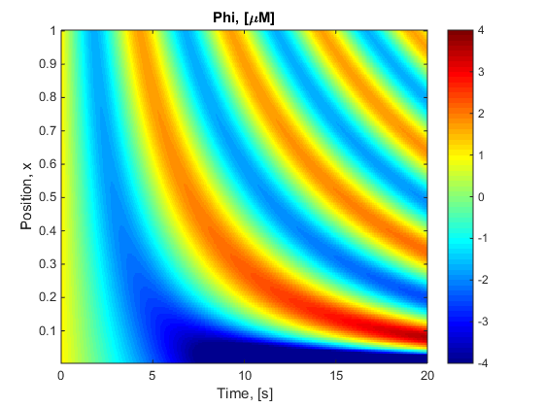

Figure 1: Holding α constant at 0 and varying β linearaly between {0,1}

From here α was changed to 0.5 and again varied β. For Figure 2 the scale has been fixed {-4,4} and thus in the dark blue region which heads to negative infinity is not viewed.

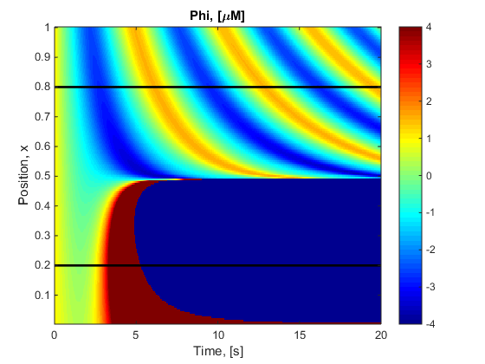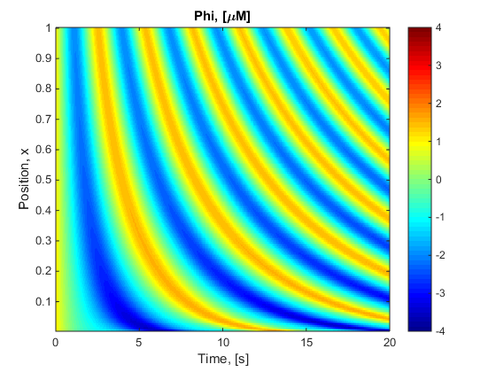

|  |  |  |
| --- | --- | --- |
| Figure 2: Holding α constant at 0.5 and varying β linearaly between {0,1} |  | Figure 3: Holding α constant at 0.5 and varying β linearaly between {0.5,2} |

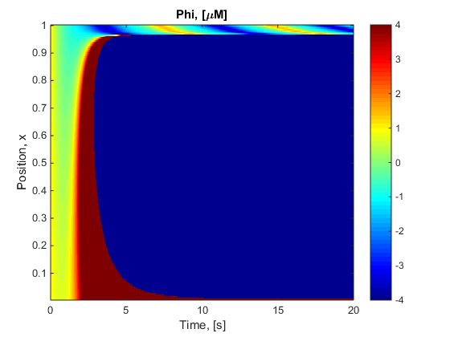 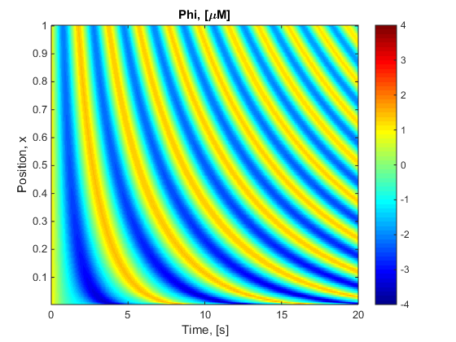

|  |  |  |
| --- | --- | --- |
| Figure 4: Holding α constant at 1 and varying β linearaly between {0,1} |  | Figure 5: Holding α constant at 1 and varying β linearaly between {0.98,2} |

Next holding Beta constant and varying alpha had an equal but opposite effect

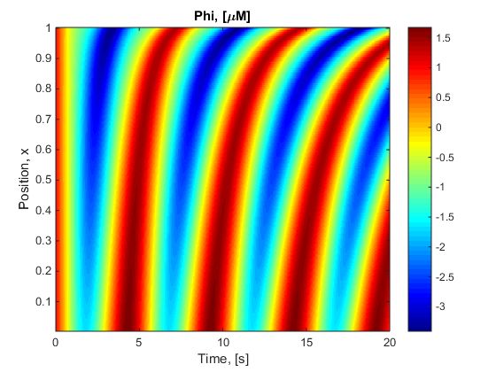

Figure 6: Holding β constant at 1 and varying α linearaly between {0,1}

# Results 3

Creating zero osculation’s; to view the diffusion it is important to have a region that initially had no osculation’s. To do this the rate of changes of Ф and V to zero for the initial conditions (Ф = V = 1).

|  |  |  |
| --- | --- | --- |
| $$\frac{dΦ}{dt} =-βV+\frac{Φ^{3}}{3}- Φ=0$$ | & | $$\frac{dV}{dt} =βΦ+ α=0$$ |
| $$-β×1+\frac{1^{3}}{3}- 1=0 ∴ β= -\frac{2}{3}$$ |  | $$β×1+α=0 ∴ α= \frac{2}{3}$$ |

Figure 7 shows Beta and alpha varying over x to obtain zero osculating.

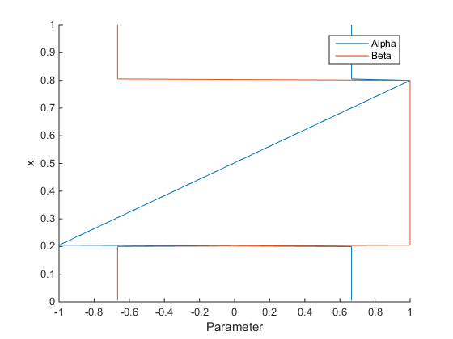

Figure 7: Alpha and Beta varying over x to obtain zero osculation’s between 0<x<0.2 and 0.8<x<1.

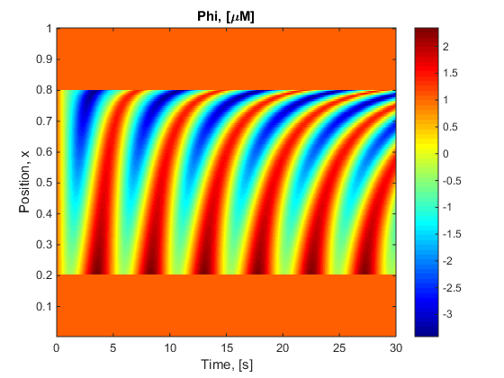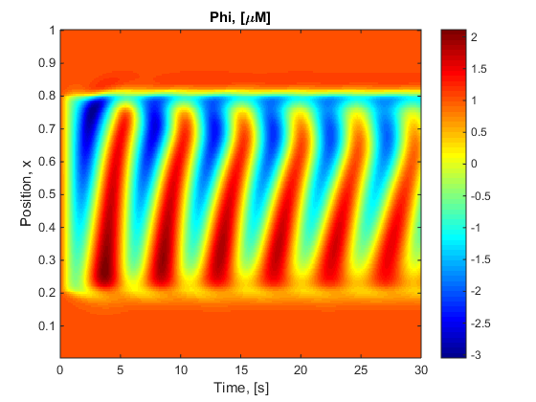

|  |  |  |
| --- | --- | --- |
| Figure 8: α and β determined by Figure 7 and Equations 1 and 2; Zero Diffusion |  | Figure 9: α and β determined by Figure 7 and Equations 3 and 4; Simple Diffusion 200e-6 |

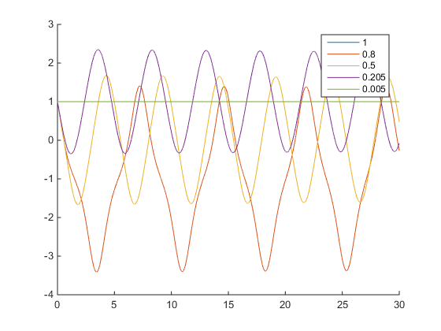

Figure 10: A few x points of Figure 8 potted over time.

# Results 4

Changing the diffusion constant, D.

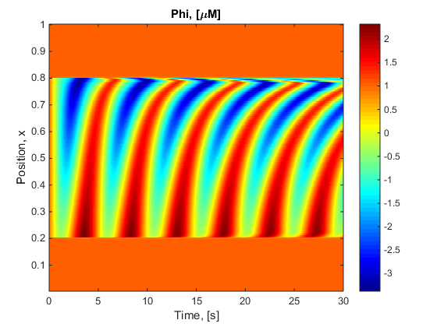 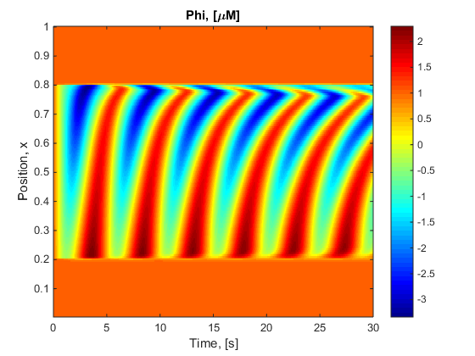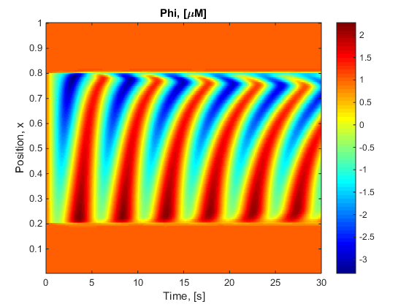

Figure 11-14: D = {1e-6, 5e-6, 10e-6, 100e-6}

# Results 5

Simulated over a long period of time

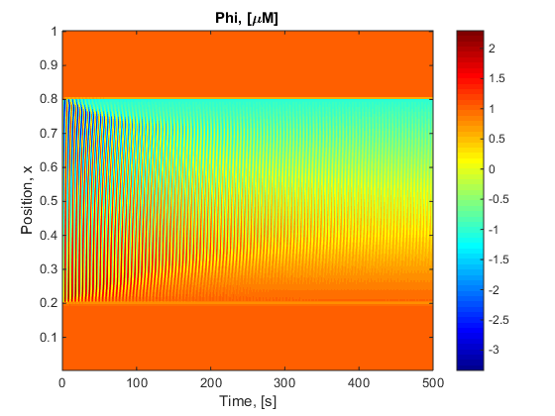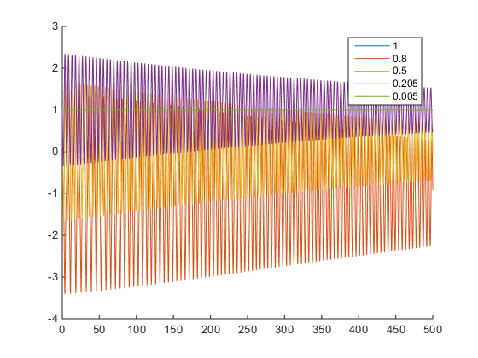

|  |  |  |
| --- | --- | --- |
| Figure 15: Diffusion, D = 5e-6 and long time, t={0:500} |  | Figure 16: x points from Figure 15 plotted over time. |

# Discussion

* Increasing alpha from 0 to 1 shows that there is an increasing instability in the results.
* At low diffusion constants the waves do not protrude into the unexpected region
* however they do form the triangle pattern of diffusion.